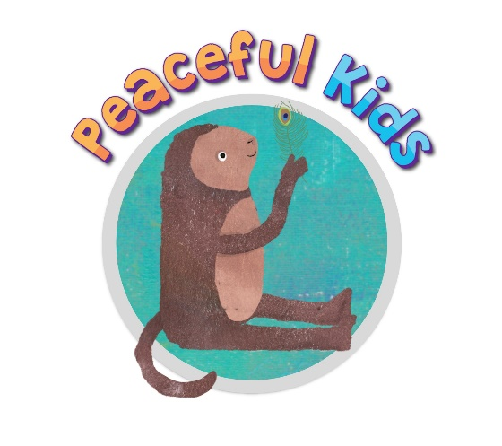

Sample introductory email / letter to schools
(to hold Peaceful Kids within schools)

Hi (Wellbeing leader / Leadership staff name)

My name is (name), and I am currently completing a ‘Certificate in Mindfulness and Wellbeing For Children’ through ‘Wellbeing For Kids’ and Meditation Australia.
As a part of my Certificate training, I am currently being trained as a facilitator of the ‘Peaceful Kids’ program. Peaceful Kids is a Mindfulness and Positive Psychology based program to lessen anxiety and stress and increase resilience in children. The program gives children the skills, practice, and support to utilise coping strategies that lessen the symptoms of anxiety and stress. This program helps children to build their emotional resilience, so they are better equipped to deal with the day to day stresses that life brings them. The program also involves parental involvement and commitment to supporting the strategies at home. ﻿﻿
To complete my practicum hours, I am looking for a school where I could facilitate 3 Peaceful Kids groups during school hours. The program runs for 8 weeks for an hour each week with 4-6 children in each group. This program would be no cost to the school or families. I have attached further information that explains the program in more depth including the structure of the program and the benefits. You can also find more information on this website www.peacefulkids.com.au

For more information on the Peaceful Kids program, I would be happy to come to your school to chat with you in person, or to run a free short parent or staff information session, which provides the opportunity to learn more about the program and ask any further questions.

If you would like to further discuss this, please don't hesitate to contact me on my mobile (phone number), or email me at (your email)

I look forward to hearing from you.

Kind regards,
(your name)

