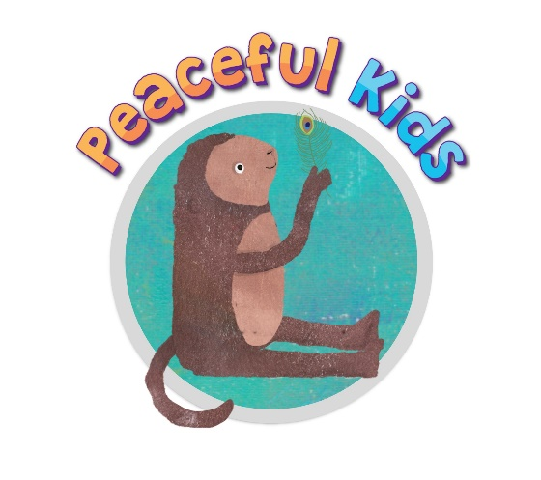

Sample introductory email / letter to schools
(to hold Peaceful Classrooms Mindfulness Lessons within schools)

Hi (Wellbeing leader / Leadership staff name)

My name is (name), and I am currently completing a ‘Certificate in Mindfulness and Wellbeing For Children’ through ‘Wellbeing For Kids’ and Meditation Australia.
As a part of my Certificate training, I am currently being trained as a facilitator of the ‘Peaceful Kids’ program. One of the components of the Peaceful Kids program is facilitating ‘Peaceful Classrooms’ Mindfulness lessons for children in the classroom.
To complete my practicum hours, I am looking for a school where I could facilitate 10 (adjust this to what you are offering) Mindfulness lessons with a class of children. This would run over a term in three different classrooms, where the children learn a range of Mindfulness strategies, meditations, and activities.

This program would be no cost to the school or families. I have attached further information that explains the program in more depth including the structure of the program and the benefits. You can also find more information on this website www.peacefulkids.com.au

For more information on the Peaceful Kids program, I would be happy to come to your school to chat with you in person, or to run a free short parent or staff information session, which provides the opportunity to learn more about the program and ask any further questions.

If you would like to further discuss this, please don't hesitate to contact me on my mobile (phone number), or email me at (your email)

I look forward to hearing from you.

Kind regards,
(your name)

